# Creating and Deploying a Static Website with Apache2:
Preparation (5 minutes)
- Ensure you have access to a Linux environment (e.g., virtual machines, EC2 instances, or local installations) with sudo privileges.

# Activity Breakdown:

# Part 1: Installing Apache2 (5 minutes):
1. Update Package Lists:
- Open the terminal and run:
sudo apt update
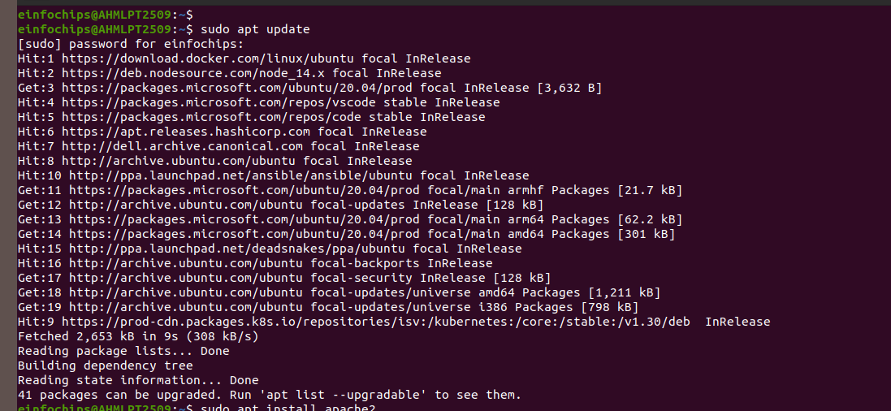

2. Install Apache2:
- Install Apache2 by running:
sudo apt install apache2
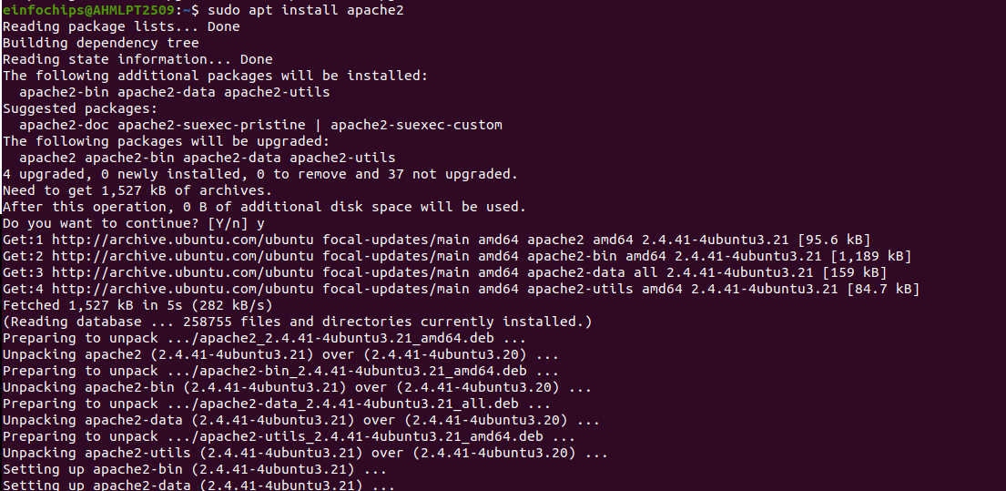

3. Start and Enable Apache2:
- Start the Apache2 service:
sudo systemctl start apache2

4. Enable Apache2 to start on boot:
sudo systemctl enable apache2

5. Verify Installation
  - Open a web browser and navigate to http://your_server_ip. You should see the Apache2 default page.

# Part 2: Creating the Website (10 minutes):

1. Navigate to the Web Directory:
- Change to the web root directory:
cd /var/www/html
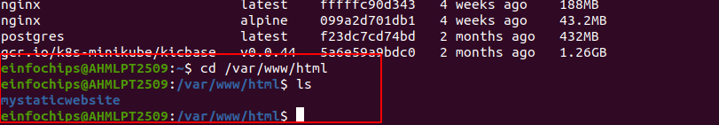
2. Create a New Directory for the Website:
Create a directory named mystaticwebsite:
sudo mkdir mystaticwebsite
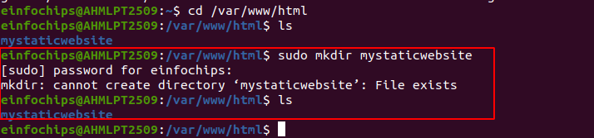
3. Change ownership of the directory:
sudo chown -R $USER:$USER /var/www/html/mystaticwebsite
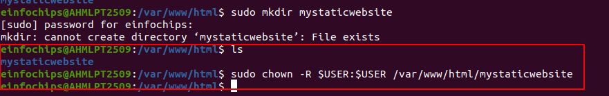
4. Create HTML File:
Create and edit the index.html file:
nano /var/www/html/mystaticwebsite/index.html
5. Add the following content:

<!DOCTYPE html>
<html>
<head>
<title>My Static Website</title>
<link rel="stylesheet" type="text/css" href="styles.css">
</head>
<body>
<h1>Welcome to My Static Website</h1>
<p>This is a simple static website using Apache2.</p>
<script src="script.js"></script>
</body>
</html>
- Save and exit (Ctrl+O, Enter, Ctrl+X).

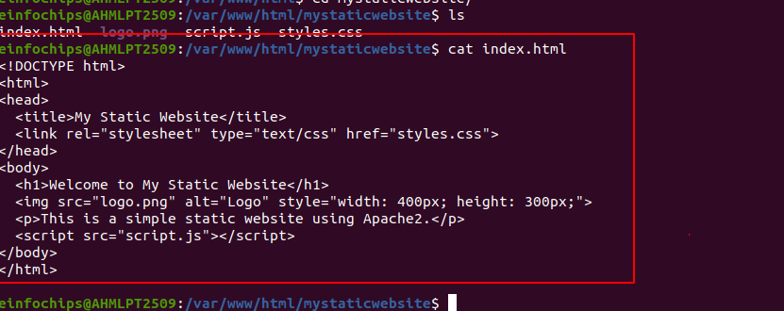
6. Create CSS File:
- Create and edit the styles.css file:
nano /var/www/html/mystaticwebsite/styles.css
7. Add the following content:
body {
font-family: Arial, sans-serif;
background-color: #f0f0f0;
text-align: center;
margin: 0;
padding: 20px;
}

h1 {
color: #333;
}

- ave and exit (Ctrl+O, Enter, Ctrl+X).

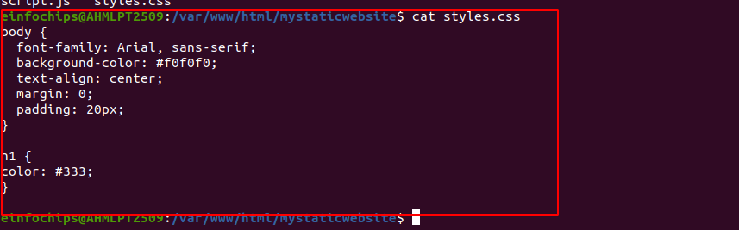

8. Add an Image:
- Download or copy an image file (e.g., logo.png) to the website directory:
cp /path/to/your/logo.png /var/www/html/mystaticwebsite/logo.pn
cp /home/einfochips/Desktop/Shital/logo.png /var/www/html/mystaticwebsite/logo.png
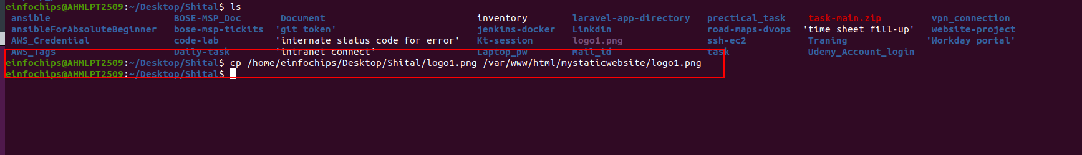
9. Update index.html to include the image:
nano index.html
cat index.html

<body>
<h1>Welcome to My Static Website</h1>
<img src="logo.png" alt="Logo">
<p>This is a simple static website using Apache2.</p>
<script src="script.js"></script>
</body>

OR
!DOCTYPE html>
<html>
<head>
<title>My Static Website</title>
<link rel="stylesheet" type="text/css" href="styles.css">
</head>
<body>
<h1>Welcome to My Static Website</h1>
<img src="logo.png" alt="Logo" style="width: 400px; height: 300px;">
<p>This is a simple static website using Apache2.</p>
<script src="script.js"></script>
</body>
</html>

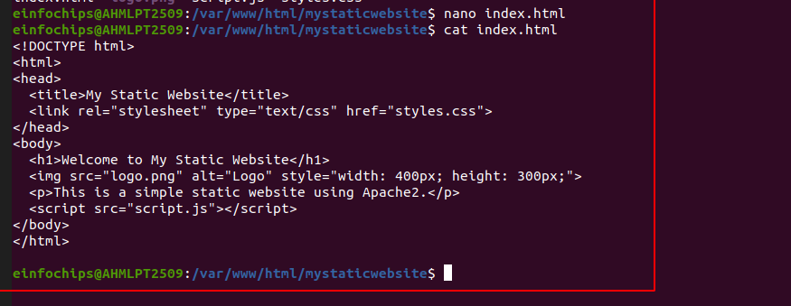

# Part 3: Configuring Apache2 to Serve the Website (10 minutes):
1. Create a Virtual Host File:
Create and edit the virtual host configuration file:
sudo nano /etc/apache2/sites-available/mystaticwebsite.conf
cd /etc/apache2/sites-available/
sudo nano mystaticwebsite.conf
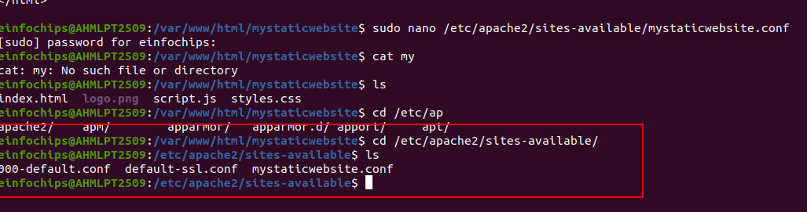

Add the following content:

<VirtualHost *:80>
ServerAdmin webmaster@localhost
DocumentRoot /var/www/html/mystaticwebsite
ErrorLog ${APACHE_LOG_DIR}/error.log
CustomLog ${APACHE_LOG_DIR}/access.log combined
</VirtualHost>
- Save and exit (Ctrl+O, Enter, Ctrl+X).
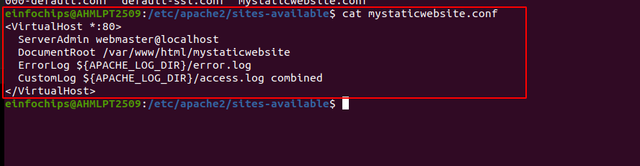
2. Enable the New Virtual Host:
Enable the virtual host configuration:
sudo a2ensite mystaticwebsite.conf
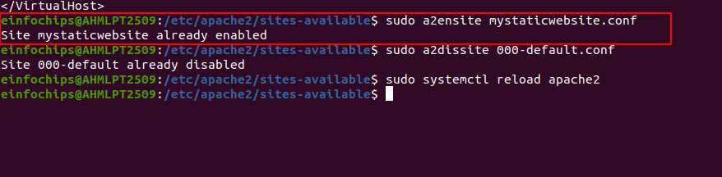

3. Disable the Default Site:
Disable the default site configuration:
sudo a2dissite 000-default.conf
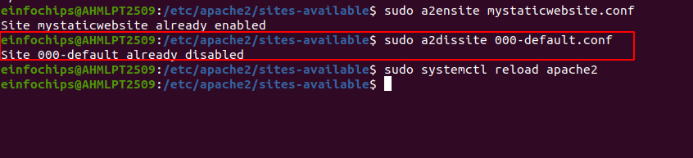

4. Reload Apache2:
Reload the Apache2 service to apply the changes:
sudo systemctl reload apache2
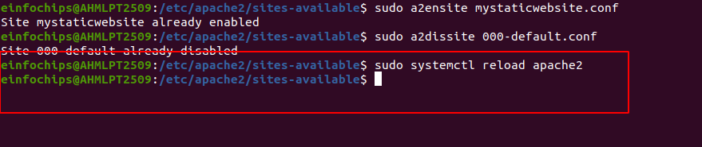

5. Test the Configuration:
  - Open a web browser and navigate to http://your_server_ip. You should see the static website with the HTML, CSS, JS, and image.

- http://127.0.0.0/
- http://localhost/

